TASK-4
TITLE:Machine learning model implementation
INTRODUCTION:
Machine Learning (ML) is a branch of Artificial Intelligence that enables computers to learn patterns from data and make predictions without being explicitly programmed. Python is one of the most widely used programming languages for ML because of its simplicity and powerful libraries such as NumPy, Pandas, Matplotlib, and Scikit-learn.
In this internship task, a Machine Learning model is implemented using Python to predict outcomes based on a dataset. The project demonstrates the complete workflow including data collection, preprocessing, training, testing, and prediction.
OBJECTIVE:
- The main objective of this project is:
- To understand the basics of Machine Learning
- To implement a ML model using Python
- To preprocess and analyze data
- To train and test the model
- To evaluate prediction accuracy
Tools and Technologies Used:
Tool/Technology Purpose
Python Programming Language
Pandas Data Handling
NumPy Numerical Operations
Matplotlib Data Visualization
Scikit-learn Machine Learning Algorithms
Jupyter Notebook / VS Code Development Environment
Machine Learning Algorithm Used:
Linear Regression
Linear Regression is a supervised machine learning algorithm used for predicting continuous values.
Formula
Y=mx+c
Where:
y = Predicted output
m = Slope
x = Input variable
c = Intercept
SOURCE CODE:
# # importing libraries
import pandas as pd
import numpy as np
import matplotlib.pyplot as plt
from sklearn.linear_model import LinearRegression
# Dataset
data = {
'Hours': [1, 2, 3, 4, 5],
'Marks': [20, 35, 50, 65, 80]
}
# Creating DataFrame
df = pd.DataFrame(data)
# Input and Output
X = df[['Hours']]
y = df['Marks']
# Creating Model
model = LinearRegression()
# Training Model
model.fit(X, y)
# Predicting
predicted = model.predict([[6]])
# Output
print("Predicted Marks for 6 hours study:", predicted[0])
# Plotting Graph
plt.scatter(X, y, color='blue')
plt.plot(X, model.predict(X), color='red')
plt.xlabel("Study Hours")
plt.ylabel("Marks")
plt.title("Study Hours vs Marks")
plt.show()
OUTPUT: Predicted Marks for 6 hours study: 95.0
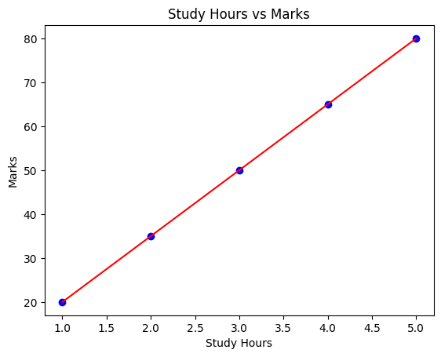

APPLICATIONS OF MACHINE LEARNING:
- Recommendation Systems
- Image Recognition
- Chatbots
- Fraud Detection
- Weather Forecasting
- Medical Diagnosis

Conclusion:
This project successfully demonstrates the implementation of a Machine Learning model using Python. Linear Regression was used to predict student marks based on study hours. The project helped in understanding data preprocessing, model training, prediction, and visualization techniques in Mac

